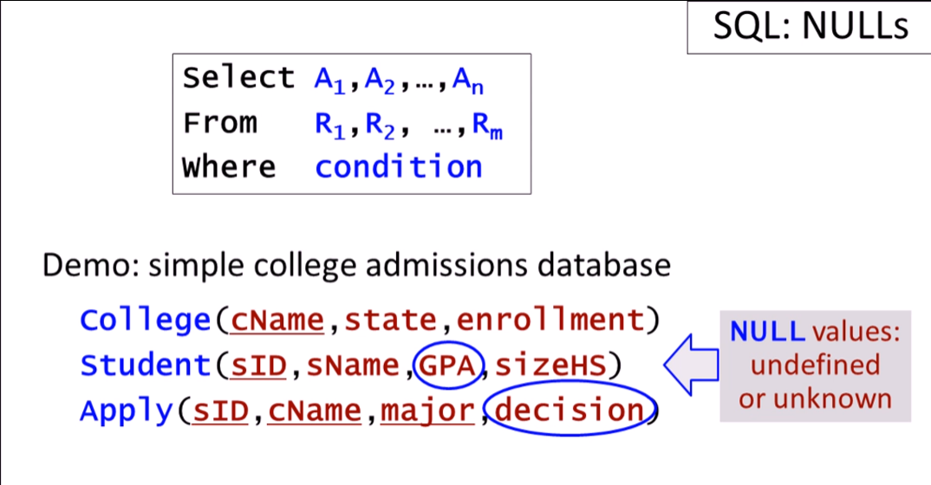



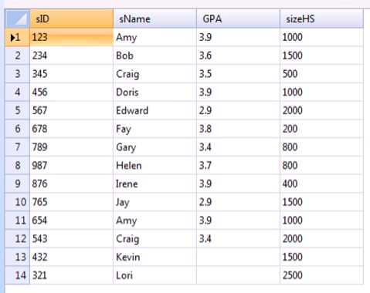

Running queries

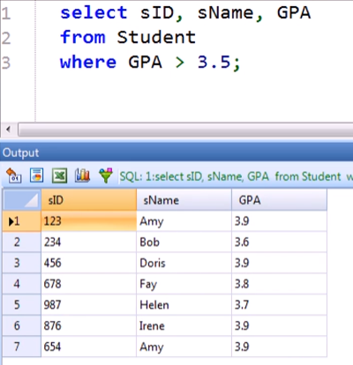

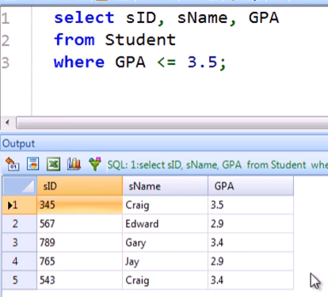

* We still don’t get Kevin and Lori because they have NULL GPAs! They are not equivalent to 0

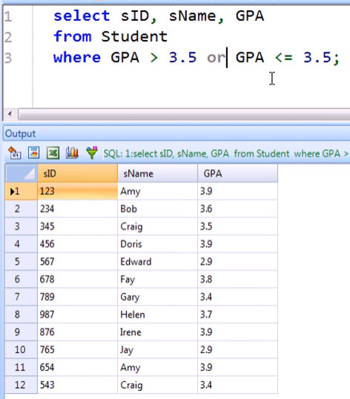

* We still don’t get Kevin and Lori because they have NULL GPAs! They are not equivalent to 0

To return, add a condition with “IS NULL”

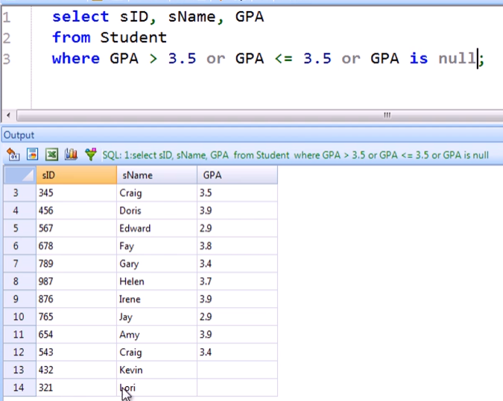

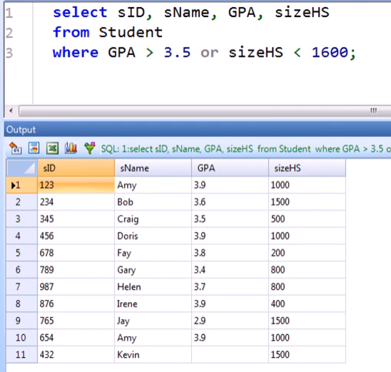

* Kevin satisfies the 2nd part of the condition, not the first one

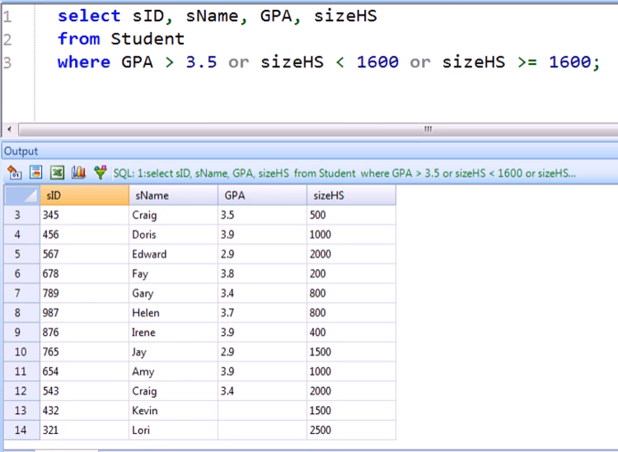

* Same goes for Lori here, 2nd part only

NULL and AGGREGATION

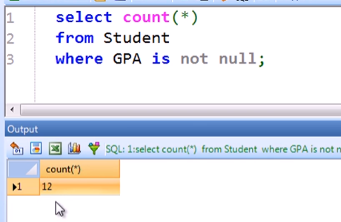

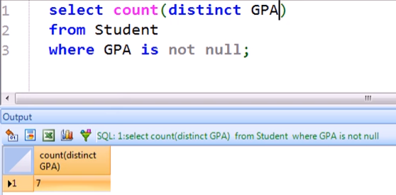

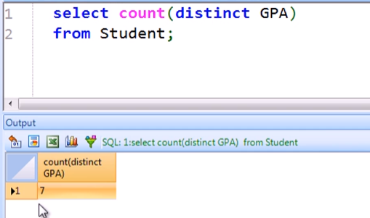

* COUNT does not include the NULL values in aggregation!

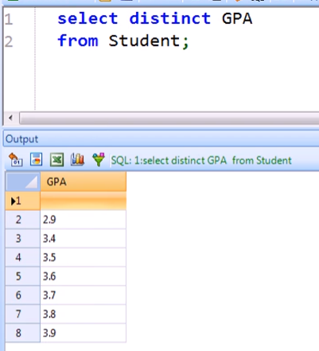

* Even though SELECT DISTINCT includes the NULL value!